Project RH134 Linux Administration II
To prevent errors in the Red Hat Academy classes and labs you must change your Internet browsers settings cookies and site permission to allow pop-ups and redirects in the following URL’s:
https://rha.ole.redhat.com/rha/
To connect to the Red Hat Academy classrooms, use the following URL:
https://rha.ole.redhat.com/rha/
Both your Red Hat login and associated email address in the Red Hat Academy are your GWU Email Address <EmailUserName>@gwu.edu as follows:
Red Hat Login: This is your GWU Email Address <EmailUserName>@gwu.edu
Associated Email Address: This is your GWU Email Address < EmailUserName >@gwu.edu
Please note that your email domain is the string that follows the separator symbol “@” meaning “at”.
You must always use the email domain “gwu.edu”. For these classes please DO NOT use other alternate domains such as “gwmail.gwu.edu”, “mail.gwu.edu”, or other similar. Always use the email domain “gwu.edu”.

Important userids and passwords in all Red Hat Labs:
Userid root password redhat
Userid student password student
Assignment description:
Submit a college level report in APA format on the due date. A single word document and PLESE DO NOT ZIP THE FILE.
The following needs to be completed for all chapters:
- After reading each section proceed to the corresponding End of Chapter Labs. The Guided Exercises are part of your reading and preparation for the end of chapter exercises and do not need to be included in the report.
- For the End of Chapter labs, the "grading script" runs constantly to check on your progress. To complete the lab, the student should open another terminal window and begin executing the steps. As they complete them, the grading script on the tab in the screenshot will update live to track their progress (the passing/failing numbers at the bottom should change).
- Read each chapter, execute the guided labs, and complete the quizzes as preparation for your execution of the Labs at the end of the chapters.
- The completion of the gradable lab exercises is mandatory, and this includes the end-of-chapter lab and Chapter 14 Comprehensive Review labs.
- Before the execution of each Lab, in the terminal windows, enter this command to set the Linux prompt equal to your first name and last name

PS1='<FirstName> <LastName> \D{%Y-%m-%d} > '
Note that there is no space before and after the first quote.
Example:
PS1='Rolando Fernandez \D{%Y-%m-%d} > '
We need to see your name and date on the prompt to give you full credit.

- At least three Screen Pictures in APA format are required. One of them must be the one that show the execution of the “lab grade … “ and the “lab finish …” scripts. For each lab that is not completed you will get a 2 points deduction.
- Each screen picture needs to be inserted into a numerated MS Word figure with title and a note highlighting your observations of the results shown in the screen picture. If you do not meet this requirement, 2 points will be deducted for each chapter with missing screen pictures.
- End the Chapter with a Summary of lessons learned section of at least 20 characters. If you do not meet this requirement, 2 points will be deducted for each chapter with missing end of lesson missing.
- The instructor gets access to a grade report from the Red Hat Academy. If you do not complete the labs in the Red Hat Lab environment assigned for the class, you will get zero points for this project.

Example of the Red Hat Certificate of Attendance. Optionally you can place it in the top of your report – Sometimes the certificate is not issued because of Errors on the Red Hat Academy software. Therefore, this item is optional.
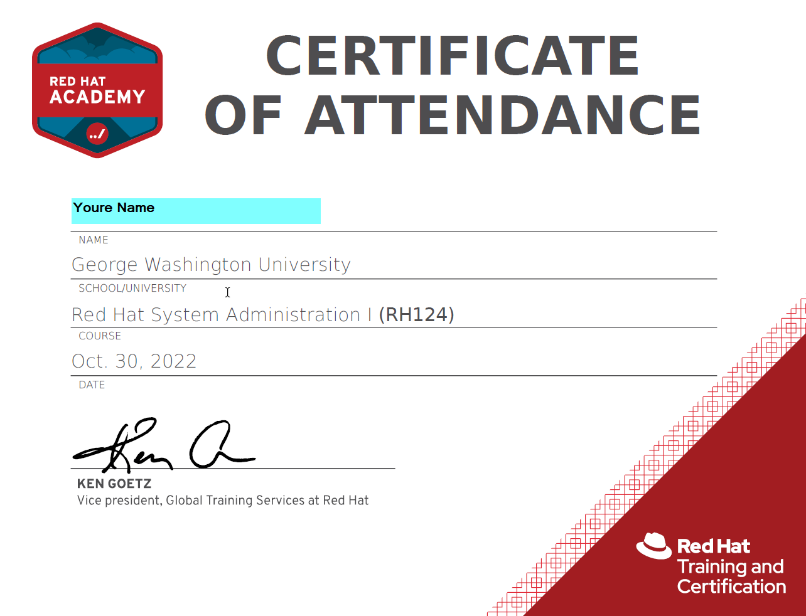

Appendix A – The Lab Environment
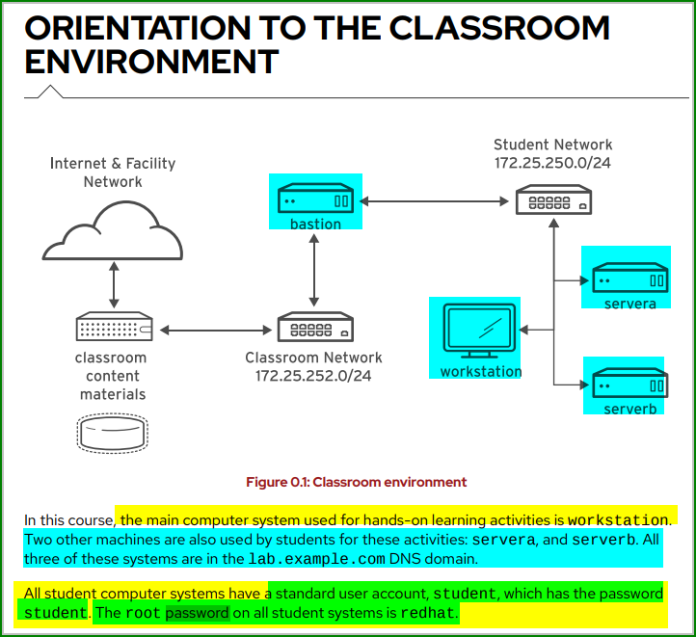
Performing Lab Exercises
You might see the following lab activity types in this course:

A guided exercise is a hands-on practice exercise that follows a presentation section. It walks you through a procedure to perform, step by step.
A quiz is typically used when checking knowledge-based learning, or when a hands-on activity is impractical for some other reason.
An end-of-chapter lab is a gradable hands-on activity to help you to check your learning. You work through a set of high-level steps, based on the guided exercises in that chapter, but the steps do not walk you through every command. A solution is provided with a step-by-step walk-through.
A comprehensive review lab is used at the end of the course. It is also a gradable hands-on activity, and might cover content from the entire course. You work through a specification of what to do in the activity, without receiving the specific steps to do so. Again, a solution is provided with a step-by-step walk-through that meets the specification.
To prepare your lab environment at the start of each hands-on activity, run the lab start command with a specified activity name from the activity's instructions. Likewise, at the end of each hands-on activity, run the lab finish command with that same activity name to clean up after the activity. Each hands-on activity has a unique name within a course.
The syntax for running an exercise script is as follows:

[student@workstation ~]$ lab action exercise
The action is a choice of start, grade, or finish. All exercises support start and finish. Only end-of-chapter labs and comprehensive review labs support grade.
start
The start action verifies the required resources to begin an exercise. It might include configuring settings, creating resources, confirming prerequisite services, and verifying necessary outcomes from previous exercises. You can perform an exercise at any time, even without performing preceding exercises.
grade
For gradable activities, the grade action directs the lab command to evaluate your work, and shows a list of grading criteria with a PASS or FAIL status for each. To achieve a PASS status for all criteria, fix the failures and rerun the grade action.
finish
The finish action cleans up resources that were configured during the exercise. You can perform an exercise as many times as you want.
The lab command supports tab completion.
For example, to list all exercises that you can start, enter
lab start
and then press the Tab key twice.
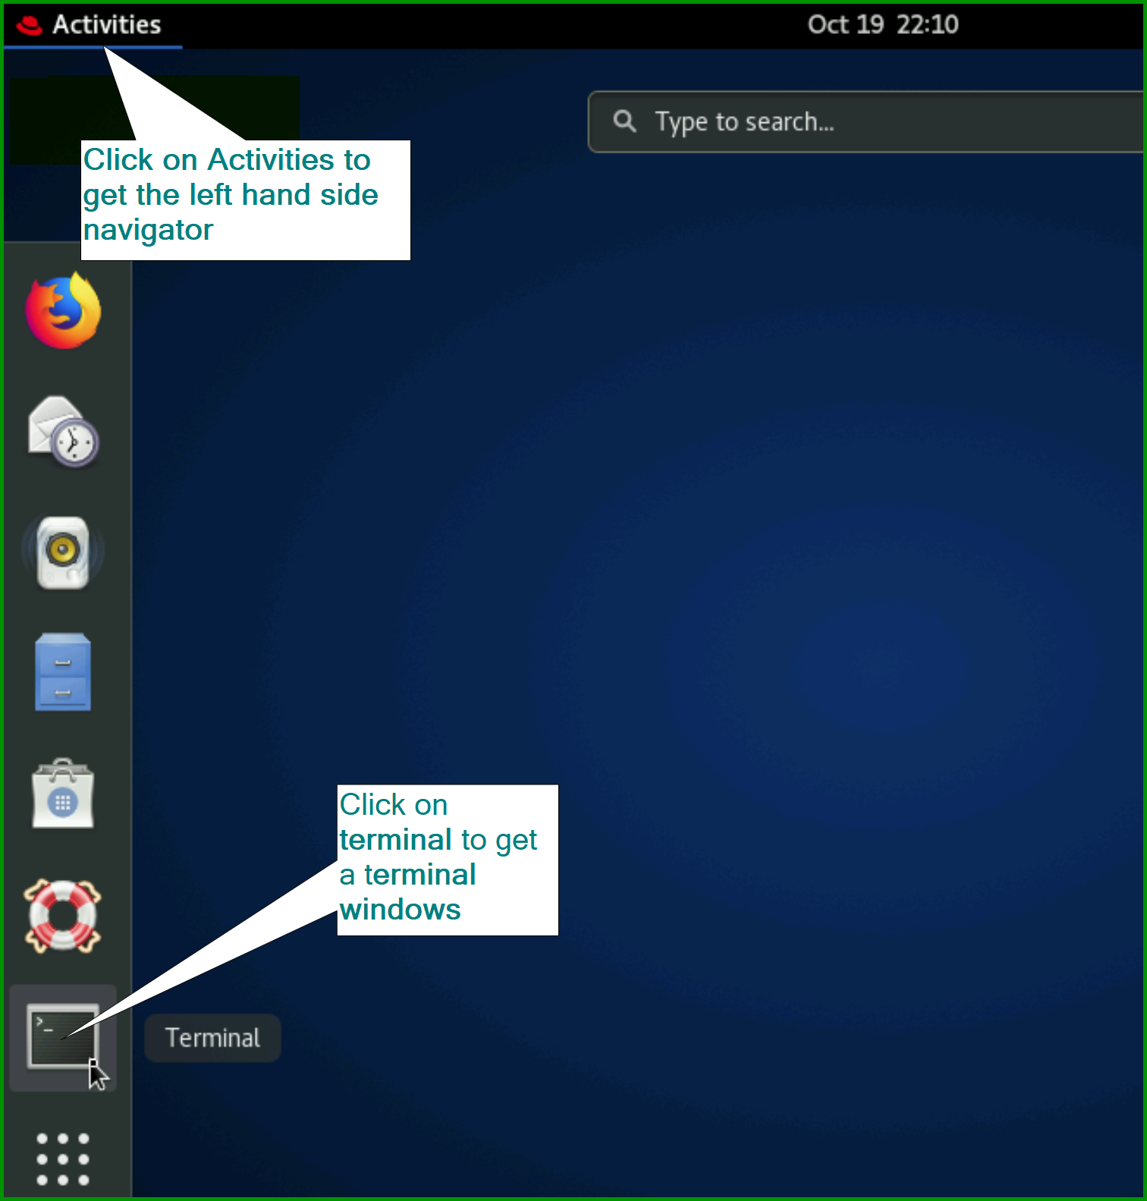
Double click on the line above the bar menu to increase the size of the terminal window.
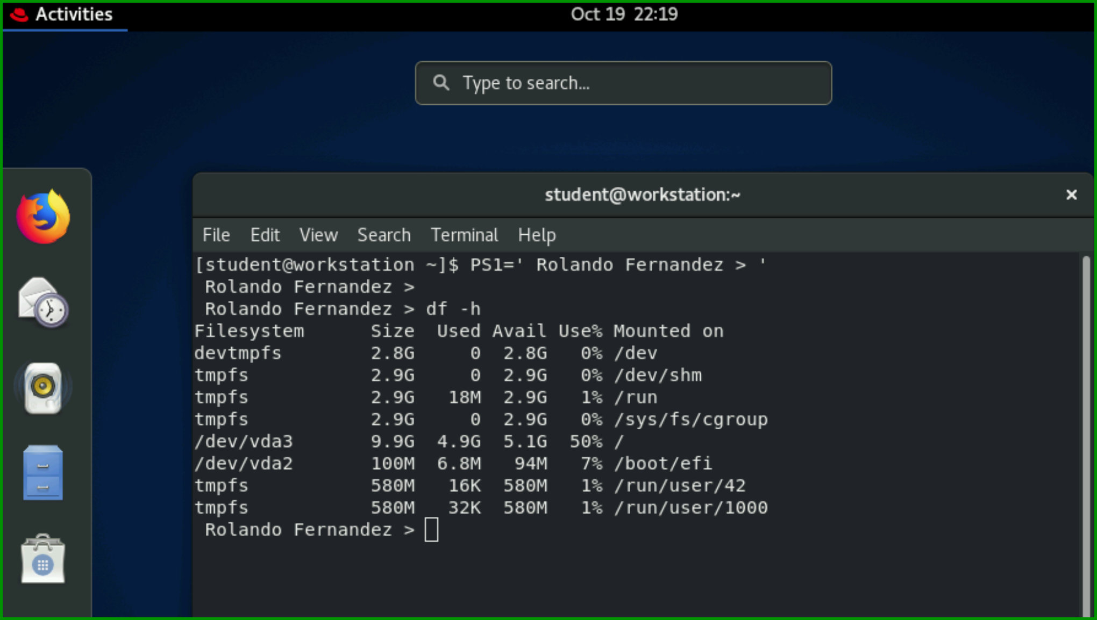

Appendix B - About Screen Pictures
Screen pictures must be in APA Format (see example below) and must be inserted into a MS Word figure. Follow the following recommendations about the figures:
- Must be numerated
- Must have a figure title
- Must have Notes to supplement or clarify information in the image This Notes must be at least 20 words. See the example below.

